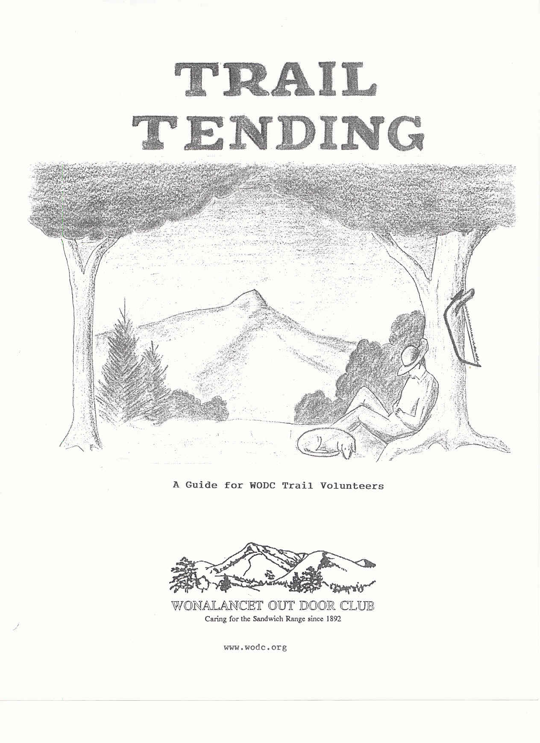

TRAIL TENDING
_A Guide for WODC Trail Volunteers
by Chris Conrod
with thanks to the Trails and Executive Committees
TABLE OF CONTENTS
INTRODUCTION (by Peter Smart) i
I CLEARING THINGS UP I-1
Brushing and Blowdown Removal
II WET FEET & LOOSE STONES II-1
A look at Drainage and Erosion .
Control
III SHOWING THE WAY III-1
Blazing and Signing
IV GOOD NEIGHBORS, GRACIOUS GUESTS IV-1
Working with the landowners
APPENDICES
A: Adopter Contract
B: Work Trip Report and Checklist
C: USFS Voluntary Services Agreement
D: Active Volunteers (as included in USFS Agreement)
E: Private Property/Volunteer Acknowledgement Sign
F: Bibliography.
G: Trails Committee Members

Introduction

There have been a number of excellent texts written on the art of trail tending, so why do we need another? Because, as any Wonalancet hiker knows, WODC trails are special. While that may seem an obvious statement, you may not realize just how unique the WODC trail system really is.

With its earliest trails being opened in the 1890's, the WODC trail system is one of the oldest in the country, actually predating the creation of the White Mountain National Forest by twenty years. The result is not only an unrivaled pride in WODC trails, but also a vital relationship with the United States Forest Service, with whom we share responsibility for the trails. These are some of the elements of our rich history that call for a Guide written specifically for WODC trails.

The WODC currently maintains 52 miles of trails, making it perhaps the largest volunteer-based trail system in the White Mountains. In 1995, volunteers performed 1500 hours of work on WODC trails, or about 29 hours per mile of trail. This work was supported by a $3385 trails budget ($69/mile), which provided necessary tools, signs, and supplies, as well as hiring a crew for vital trail restoration.

By comparison, the AMC maintains 327 miles of trails in the WMNF. In 1995, volunteers contributed 11,300 hours to the AMC trails program (34 hours per mile), supported by expenditures of $328,310 ($I004/mile). Although the AMC may be the best known, other groups including the RMC, CTA, CMC, OHA, SSOC, WVAIA, and SLA playa vital role in WMNF trail maintenance. But despite the significant contributions of these "Cooperators", the USFS still maintains the majority of the 1465 miles of hiking trails in the WMNF.

Although the USFS oversees most of our 52 trail miles, 11 miles actually lie outside the WMNF. This makes relations with private landowners a vital part of the WODC trails program. WODC adopters serve as the Club's ambassadors, and we are largely dependent on you to maintain good relations with landowners. Take every opportunity to listen to their concerns. Generations of future hikers will have you to thank as we continue to enjoy the hospitality of our trail hosts.

But perhaps the most distinctive feature of the WODC trail network is the high percentage that lies within the Sandwich Range Wilderness. 30 miles of our trails (58%) lie within this Congressionally designated area. By comparison, only 14% (46 miles) of AMC maintained trails lie within Wilderness.

Wilderness is well known for its prohibition of vehicles and motorized equipment. But as discussed in this Guide, Wilderness has many other implications for hiking trails. While these provisions are sometimes viewed as unnecessary "restrictions", I urge you to consider the substantial benefits they convey. With the demands on public lands increasing steadily (including recreation), the few tracts of federal Wilderness are the only hope that future generations may experience an environment "untrammeled by man." As we strive to help the hiker enjoy the woods, remember that our greatest challenge is to protect the woods from the hiker.

Peter Smart, WODC Trails Chair - May, 1998
Chapter I
CLEARING THINGS UP
BRUSHING AND BLOWDOWN REMOVAL

The primary responsibility of the WODC trail adopter is to maintain a pathway that provides an obvious and practical route for the hiker. This task should be performed with an eye toward aesthetics and conservation.
No easy task! Theory and individual opinion could bog us down before we set foot on the trail. How wide should we clear? How high? How often? Should this tree be pruned or removed? Should we even be clearing trails in Wilderness? These questions and countless others have been asked of and by the trail gurus and in many cases consensus eludes us.
Nevertheless, the following guidelines are offered in an effort to standardize WODC trail maintenance and provide to the hiker a suitable and attractive route.

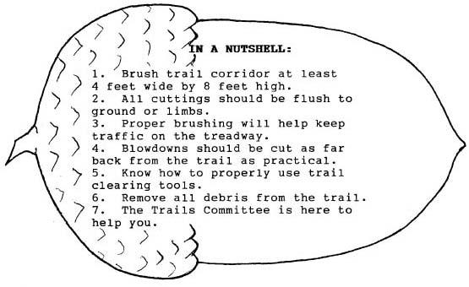

BRUSHING
In general, WODC trails should be cleared so that a large person with a full frame pack can walk the trail after a rain storm without getting soaked. Allowing for regrowth between brushing sessions, the recommended width is four or five feet with a height of eight feet. If the trail is used frequently in the winter, the adopter has the option of clearing higher to allow for snow cover.
I-2

A five foot width may seem extreme but when put into practice it will guarantee an adequate path for at least a year. Plants and their branches are very adept at finding and occupying open spaces. A two or three foot wide clearing will fill up quickly. Branchless tree trunks are allowed within this clearing width as long as the hiker does not have a hard time squeezing between them. In fact, these larger trees will help shade the trail and retard understory growth.
The intent is not to have a five foot wide treadway (the surface area of ground that is actually walked on) but to keep that area clear for the entire period between brushing sessions. In most cases the treadway will remain at about 18 to 24 inches in width. Exceptions occur when a trail is very heavily used or when erosion and drainage problems exist.
Plants that are entirely removed should be cut flush with the ground. Branches should be cut flush with the trunk or limb from which they are removed. This results in a natural appearance and eliminates potential hazards to the hiker.
Try to avoid overpruning trees and never remove the top. This is not only unsightly but also encourages lateral growth which increases your later work and produces an even uglier tree. N.H. Parks Department suggests that not more than one third of a tree's branches be removed.
Sometimes removing one third of the branches is not enough to provide a proper clearing. In this case it is best to remove the entire tree. In fact, many adopters have come to the conclusion that if a small sapling needs pruning the best course of action is to remove it because it will present problems later on.

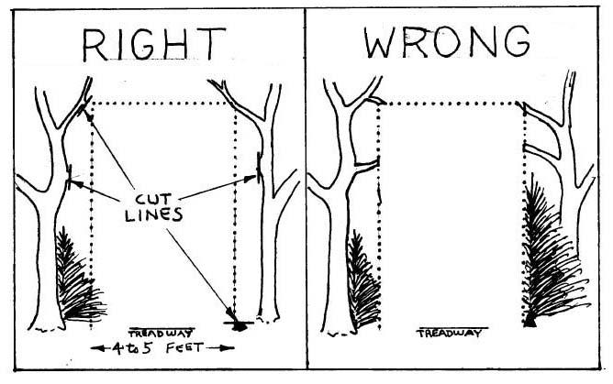

I-3

Unfortunately, the same respect for nature and stewardship ethic that led us to become trail maintainers sometimes prevent us from doing a thorough job. Trail clearing is not for the squeamish. If a tree is a hindrance it must go.

SPECIAL CONSIDERATIONS
Good brushing practices not only facilitate unimpeded passage but also help guide the hiker along the trail. Signs and blazes should be kept clear of any growth that obstructs visibility.
The adopter should remember that heavy brushing will sometimes open up alternative routes, resulting in multiple treadways. If this situation cannot be avoided by judicious brushing, the less desirable routes should be blocked by placing downed limbs or logs to keep hikers on the intended treadway. This practice is commonly called "brushing in".
At some point, most WODC trails slab along the side of a hill. Hikers have a tendency to walk on the downhill side of the trail, probably because the lower (relatively) vegetation provides a more inviting route and better view. The result is an almost imperceptible but steady downhill migration of the treadway, which is intensified when an unwary trail brusher concentrates mostly on the lower side of the trail.
When this occurs on a graded route such as an old logging road, the treadway often ends up on the very edge of the bank, which can lead to erosion problems. There are even cases where this downhill movement has resulted in the trail ending up in the outflow ditches that carry water away from the trail. Observe Dicey's Mill Trail to see examples of this.
By keeping aware of the terrain and favoring one side of the trail while brushing, usually the uphill side, the adopter can help guide foot travel toward the most stable route.
Another problem many adopters face is hobble bush. When this weed overtakes a trail it can drive the most dedicated adopter to tears. Annual sessions with loppers are no match for this fast growing invasive plant.
The solution is an intensive brushing session with a large crew. If your trail is inundated with this weed, perhaps you should contact the Trails Committee for help.
After the hobble bush has been cut back to a width of five feet, annual sessions with a swizzle stick will keep the weed in check. The trick is to stay ahead of it. As long as you are working with year old growth, the swizzle stick will work fine.
The extent of brushing and tree removal should be limited to providing a clear path. View clearing is not allowed in federally designated Wilderness areas nor is it endorsed by the club. We have permission from the land owners to clear only the trails.

I-4

BLOWDOWNS
There is some debate over when a blowdown should be removed, especially in Wilderness. Some adopters believe all dead wood should be removed while others think that only those blowdowns that significantly impede passage need to be removed. The decision is yours as long as the following considerations are given.
Any fallen or leaning wood that requires the hiker to crawl under or climb over should be removed. This not only facilitates travel but also lessens the likelihood of bootleg relocations. Most people confronted with an obstacle will search for a route around it. On a well used trail it is only a matter of weeks before a new route is established. The sooner a blowdown is removed, the less damage is done to the surrounding area.
It is best to remove as much of a blowdown as possible. The goal should be not only to clear the path for travel but also to retain a natural appearance. Sawed ends of logs protruding into the trail detract from the wilderness experience and can also impede future brushing efforts.
If the tree is small enough, it can be dragged off the trail butt first or cut in sections and removed. Larger trees usually require two or more cuts to remove the section blocking the trail. Cut this section as large as possible to lessen the visual impact of the remaining pieces.
Some large blowdowns that fall nearly parallel to the trail are best moved by rolling or shifting with pry bars. You would be amazed at the size of a tree that can be moved this way. If you have such a monster on your trail, contact the Trails Committee for help.
After the path has been cleared, be sure to check for and remove any branches extending into the trail clearing. Protruding broken branches can cause serious injury; to hikers.

TOOLS
Personal preferences not withstanding, there are a few tools that can be deemed essential for trail clearing and others that should be used only with caution, if at all.
Loppers, also called pruners, and saws are the two most useful tools for brushing. Loppers are the best means of cutting the small woody growth that reappears between clearing sessions. They are safe and effective. The double action anvil type has the most cutting power. Loppers are good for anything up to the size of your thumb. Larger branches are best removed by saw. For brushing, a 21 inch bow saw is generally adequate.
The swizzle stick, as mentioned earlier, is excellent for removing new low growth. It is swung like a golf club and can clear a sizable area in a short time. Just remember to keep both hands on the handle, wear heavy boots and long pants, and make sure no one is within twenty feet of you.

I-5

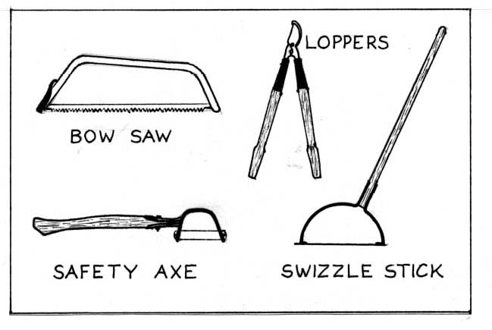

Special considerations should be given if the trail adopter chooses to use machetes or safety axes. Although they are capable of cutting fairly large branches swiftly, it is almost impossible to cut flush to the ground and they tend to leave jagged "punji sticks", which are a hazard to hikers. Safety axes also have the nasty habit of losing their blades, which can be hard to find on the forest floor. Be sure to consider these aesthetic and safety issues if you choose to use either a machete or safety axe.
For blowdown removal, it is basically a choice between saw and axe. For Wilderness applications, we must remember a saw is powered by the operator; chain saws and other mechanized tools are not allowed, nor appreciated by most hikers on any trails. The extra work entailed in cutting blowdowns by hand is more than compensated by the ease of toting a hand saw and the quality experience of doing the work in a less invasive manner.
A 36 inch bow saw is light weight, relatively safe, and will handle most anything an adopter would want to cut by hand. It is not too cumbersome to pack provided it has a blade guard. The primary drawback to the bow saw is its tendency to get hopelessly pinched in large logs.
Careful scrutiny of the blowdown before beginning is needed to prevent pinching. The saw cut should be made on the side of the log that will open when the log sags. Often times this is on the bottom of the log which although difficult, is usually possible; and beats the alternative of leaving the blowdown in the middle of the trail with a broken saw blade protruding from it.

I-6

Axes don't have the pinching problem, and many adopters prefer them over saws. A well sharpened axe in experienced hands can make quick work of the meanest blowdown. The key word is experience. Carelessness leads to footlessness. Until you feel confident with an axe, work slowly and carefully and always have a partner with you.
With the exception of the axe, all the tools described here are available in the WODC tool trailer and most can be found in the tool locker at the Ferncroft kiosk. Any tools borrowed from the tool locker should be signed out on the form hanging on the door. By signing this form you are acknowledging responsibility for proper use and care of the tool. Be sure to sign the tool back in when it is returned.
The safe and proper use of these tools can only be taught by a hands-on demonstration. If you have any questions on tool use and safety, don't hesitate to contact anyone on the Trails Committee.

CLEAN UP
A properly cleared trail has a treadway clear of any debris. Cuttings left in the trail have a messy, unnatural appearance and in some cases may linger for years. All cuttings should be removed from the treadway and preferably disposed of in an inconspicuous manner. As previously mentioned, blowdowns should be cut well back from the trail and dragged out of sight if possible.
This is a good time to scrutinize the result of your labors and determine if any alternate, unpreferable routes exist. They can be brushed in using cuttings and/or previously downed limbs as discussed in the Special Considerations section of this chapter.
When disposing of debris, keep an eye out for drainage channels. Do not place anything where it might block the flow of water. The water may end up in the trail. There is a tendency of trail maintainers to fill in low areas with discarded brush that can dam up runoff and cause major problems. The importance of good drainage cannot be over emphasized.

SCHEDULING
How often you decide to schedule your work trips is up to you, but we do request that you adhere to a few minimal requirements.
The most important work trip of the hiking season is the first. The trails take a beating over the winter. Due to wind and snow fall most of the blowdowns occur during this period. It is advisable to plan your first trip to coincide with the final snow melt, which is usually in mid to late May for the higher trails.
You may just want to concentrate on blowdowns on this trip. After all, it's been a long winter and you won't want to haul in too many tools on your first hike of the season.
I-7

This is also a good time to check out the general condition of the trail, including water/mud problems and the state of the drainage structures, which will be discussed in the next chapter. There is nothing like a good spring run-off to test the limits of waterbars and ditches. This is the time to look for problems.
Keep in mind that this is also the season when the trail is most delicate and vulnerable to traffic. Tread lightly and if you come across a section of trail that is particularly wet and loose it may be best to postpone any work in this area until drier conditions prevail.
Brushing can be done any time of the hiking season. This writer prefers the late summer and early fall. The bugs are mostly gone and seasonal growth has all but ceased. What is removed at this time will remain removed until the growing season starts up the following Spring.
The most important thing is to brush the trail thoroughly every year. If you keep on top of it, the work is relatively easy; if you let it get ahead of you, it will feel like there is no catching up.
If you can, you may want to do a trip in November, before the snow falls. There is almost always at least one wind and rain storm in the fall that causes some trail damage. Whatever you get on this trip will be work you won't have to do in the Spring and the winter trekkers will thank you for it. This is especially important on the more skiable trails.
It is hard to give an estimate of the total time required to keep a trail in good condition. Length, soils, wind exposure and vegetation all fit into the equation. If' you find that your trail needs a greater time commitment than you can afford let the Trails Committee know. We are always willing to work out an agreement that satisfies both the volunteer and maintenance requirements of the trail.

Chapter II
WET FEET & LOOSE STONES
A look a Drainage and Erosion Control

The preceding chapter outlined the basic responsibilities of the trail adopter and therefore, you are armed with all the knowledge and wisdom you need, right? Wrong! Yes, the job of the adopter is to keep the trail clear for enjoyable and safe passage, and no, we do not expect you to build waterbars and dig ditches; but you are the one person that visits the trail on a regular basis. You are the one that sinks to your knees in the mud hole. You are the one that gets caught in the torrential downpour and witnesses fist sized stones being swept down the trail.
We need you to be our eyes and ears. The Trails Committee tries to have at least one member on each trail every year. To be honest, we have never succeeded. It is up to you to let us know what is happening on your trail.
This chapter and the next two chapters provide a concise look at some of the perennial concerns that we, as trail tenders, all must address. We hope that after digesting this information you will look at your trail from a new perspective that will help you identify problems before they become severe and understand the ramifications of all trail activities, be it usage or maintenance.

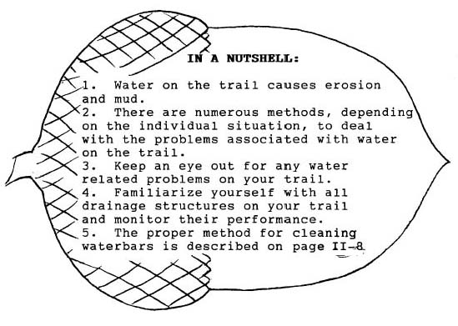

II-2

WATER IS BAD
Actually, it is our feet that are the culprits. It is the continued treading that allows the water to collect on the trail, but since we are not about to turn in our hiking boots and sprout wings let's assign the blame to water. Water is bad. Moving water takes the soil with it and creates gullies. Standing water deposits silt and sand, resulting in mud holes.
From the moment a trail is created the process starts. The hikers arrive, the plants are trampled and die. The now dead roots and forest duff are ground into flour and the soil becomes unstable and compacted. An ever so slight depression is formed and then the water begins its dirty deed.
Sheet runoff, best described as uncontained flowing surface water that appears after rain storms, is intercepted by the depression, and ground water close to the surface springs from the edges as the treadway slowly sinks. On trails with a considerable slope the water flows down the trail, scouring and eroding the surface and ultimately resulting in a gully. In level areas and natural concavities the water collects along with fine soil particles and organic debris, giving birth to the classic mud hole.
In theory the solution is simple: get the water off the trail. More important, remove the water at its source, before it can inflict any damage. When drainage and erosion control is considered during the planning stage the task is relatively easy. Proper trail design eliminates the need' for many drainage structures and facilitates the construction of those that are required. When the problem isn't addressed until decades after trail construction the task becomes monumental.
Unfortunately for us, WODC trails fall into the later category. Our long and rich history of trail building has left us with an undesirable legacy of abused and tortured trails. The fault lies not with our predecessors but rather with their historical placement and, of course, the unprecedented rise in popularity of back country recreation that began in the 1970's.
So now we are not only faced with the task of removing water to prevent trail damage, but also we must deal with those areas that are so deeply scoured it is virtually impossible to remove the water by using conventional means.
When faced with this additional dilemma we are tempted to throw up our hands in total frustration, abandon the mutilated section and relocate the trail to new ground. In some cases this may be the best solution, but we have an ethical responsibility to deal with our mistakes in a more direct manner. Our actions should be those of stewards, not exploiters.
Generally, relocations should be avoided for two reasons. First, relocating the trail does nothing to address the damage
II-3

caused on the original path. Often times once the water has scoured out a route it will continue to do damage even after the trail has been abandoned. Second, alternative trail routes in the same area are likely to pose the same problems. If the trail can be moved to a site where soil and slope conditions are more suitable, then fine. But moving a trail from one delicate area to another is counter- productive.
Over the years the role of trail workers has changed dramatically. We are no longer the tamers of wilderness, but its protectors. Nowhere else is this new role more evident than in the job of drainage and erosion control.

REMOVING THE WATER
When dealing with water removal it is always important to remember two things. First, it is best to remove water at the source. Find where the water is coming onto the trail and provide a route of egress at that point or the nearest downhill site that is practical. Second, the simplest solution is the best solution.
The ultimate simple solution is to have a treadway that will shed water on its own. This is called outsloping and is most commonly used on trails that are slabbing across or diagonally up a slope. It is most effective on relatively dry soils and will shed any sheet runoff originating above the trail.
Outsloping is accomplished by sidehill grubbing (digging into the upslope side of the treadway and pulling. the loosened material down) and grading the treadway to slope towards the downhill side sufficiently to allow water to drain off the trail rather than down the trail. A word of warning; the steeper the hillside, the less stable the treadway. In extremely steep situations retaining walls or cribbing would be required.
On hillsides having wetter soils, insloping will sometimes work. As the name implies, this is simply out- sloping done in reverse. Instead of shedding water across the trail, it collects water on the uphill side. This will usually provide a dry treadway but we are still stuck with the problem of removing the water before it causes erosion.

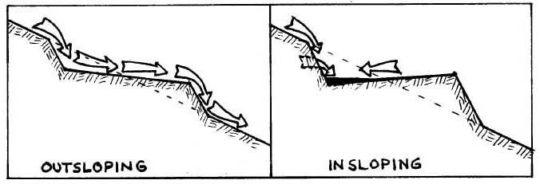

II-4

Insloping has to be employed either above a natural water shedding site on the trail or in conjunction with some other drainage device, which complicates matters. It also causes hikers to walk on the downhill side of the trail which may lead to further wear and erosion problems. It should only be used when sidehill seepage is heavy and frequent enough to render outsloping ineffective.
Interceptor Ditches are a variation of insloping. A well defined ditch is dug on the uphill side of the trail to collect runoff and seepage. This allows a flat or outsloping treadway but still requires other provisions to ultimately remove the water.
Waterbars are probably the most recognized means of coaxing water off the trail because they are the most visible. The idea is simple and effective as long as a handful of rules are followed. The waterbar should extend beyond both edges of the trail and be angled at 30 to 45 degrees (referenced to perpendicular to the trail). It should be sloped enough to keep the water from depositing any debris without scouring out the bottom of the bar.
The ditch extending from the end of the bar should be long enough to ensure the water does not return to the trail and should have a cross section shaped like a low amplitude sine wave (well rounded edges and bottom, and wider than it is deep). On steep slopes it is good to have a step above the water bar to slow velocity and one or more steps below to stabilize the treadway.

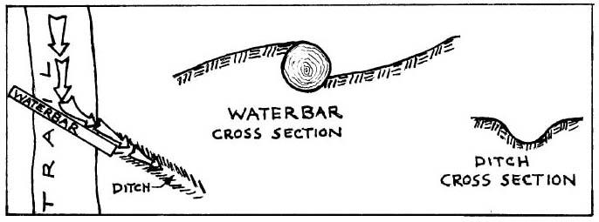

If you take an inventory of all the waterbars on your trail you will probably notice that many have at least one deficiency. For some this may be due to poor construction or maintenance but for most it is simply because site constraints limited what could be done. The result is less than perfect but should be the best possible solution for that situation.
What really counts is how effectively the waterbar removes runoff from the trail and how well it encourages hikers to stay on the treadway. The latter is easy to discern. Where do you want to step when passing the bar? If you pass directly over it everything is fine. If you tend to go around it or over one end we have a problem, because the wear and tear of foot traffic

II-5

will eventually provide a route for the water to bypass the bar.
Determining a waterbar's runoff removal ability takes a little more study. The most conclusive means involves getting ourselves soaked in the process, and while it pays to take advantage of coincidental occurrences none of us (OK, maybe a couple of nuts) are willing to head for the hills at the first sound of thunder. However, a good "dry run", if you will, involves the use of a golf ball.
After arriving at the test site and carefully looking and listening to be sure no hikers will witness your lunacy, release the ball on the lowest part of the treadway about five feet uphill from the waterbar. If everything is perfect the ball will travel at a moderate speed and with minimal bouncing down the trail, along the face of the waterbar and a considerable distance into the ditch. If the ball stops anywhere before reaching the ditch there either isn't enough slope or there are too many obstacles. If, on the other hand, the ball ricochets around like a pinball and/or goes careening out of sight down the trail we also have a problem.
The golf ball test is only useful on a freshly cleaned and groomed waterbar (a topic to be discussed later), and even then it has a limited usefulness, but we hope it will help you visualize the mechanics of a well designed and maintained waterbar.
On more moderate slopes earth bars, drainage dips or swa1es can be substituted for waterbars. These devices are built similarly to waterbars but do not have the log or rock bar. Instead, earth removed to create the dip is used to build a berm directly down slope. The advantages of this method are speed and low impact, both visually and environmentally. A big disadvantage is the susceptibility of the berm to erosion from both traffic and water, requiring a large amount of maintenance.
Cu1verts, switchbacks and reverse grades are other methods used for drainage and erosion control but since they require consideration during the planning stage you are unlikely to see many of these on WODC trails. Suffice it to say they exist as options to the trail worker.

DEALING WITH OUR MISTAKES
So we have all our drainage structures in place and working well. The water is off the trail and the hikers are staying on the treadway. Now, what are we going to do about the yawning chasms on upper Walden Trail? How do we deal with the hundred feet of muck on Kate Sleeper Trail? We owe it to the forest, to the memory of the people for whom these trails are named and to ourselves to address these problems.
Deep gullies pose the biggest problem. They form on steep slopes where the trail goes straight up; a difficult situation for preventive measures, never mind attempts at reconstruction. Even with a drainage device at the head of the gully we will

II-6

still have water coming in during storms. The best we can do is try to control the flow (velocity and location) and provide a treadway acceptable to the hiker that will at least stop the erosion, if not reverse the process.
Steps are the most common means of stabilizing gullies. They retard both water and traffic erosion by placing immovable objects in the path. They are quite effective in smaller gullies and are the next best thing to filling and hardening back to the original grade.
More effective than steps but less well received by hikers are check dams. These are basically steps whose tops are above the treadway. They slow the water, allowing the soil to settle out, and if properly installed will eventually fill in and serve as steps. If enough soil is being carried down the trail, successive check dams can be added over a period of time until eventually the treadway is brought back to original grade.

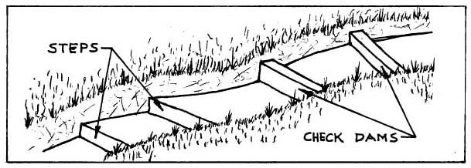

We must remember though, that this soil is coming from somewhere else. There is a tradeoff here that should be carefully considered, but if soil is being carried by the runoff anyway, we might as well take advantage of it.
There are some places on WODC trails where we just can't get rid of the water. The treadway has sunk below the water table and no amount of ditching will remove it. These places are where mud holes are born and the only option, short of relocation, is to build a raised, hardened treadway.
The traditional method of dealing with this problem has been puncheons, log bridges with cross members that rest in the muck. Puncheons have gone out of vogue recently for a number of reasons, mainly because they have a limited life span and require almost as much work as more permanent measures. Add the fact that they give an artificial man- made look to the trail and you can see why many people would rather not see them in wilderness.
Besides suffering all the drawbacks of puncheons, corduroy also gives poor, slippery footing and requires an inordinate amount of raw material compared to the surface area covered. This method has not been extensively used in recent times except for vehicular access.

II-7

Stepping stones are the quickest fix and do an excellent job on short sections of wet trail. Hikers will try to avoid them unless they are properly spaced, large enough to have a solid, stable look and provide an ample flat surface for stepping.
Causeways, turnpikes and hardening are all variations of the more ambitious method of reestablishing an entire treadway. They are often built in conjunction with ditches, cribbing, open culverts and whatever else is deemed necessary to provide a solid path while allowing for any drainage available for controlling water level.
These methods can in the truest sense be called trail reconstruction. They require a large amount of time and material but in many cases are the best means of correcting trail problems.

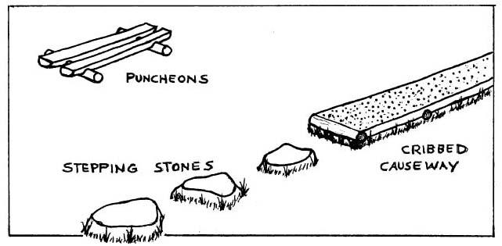

MAINTENANCE: WHO DOES IT?
The quintessential waterbar is a rare, almost mystical object. It not only efficiently removes runoff but cleans itself in the process. This rarity is most readily recognized in the field by the imprints of knees where pilgrim trail tenders have knelt to revere its glory.
But alas, the other 99.9% require periodic grooming to insure continued performance. Without this maintenance, the waterbars will eventually fill in with soil and organic debris which will eliminate their usefulness, sometimes causing them to resemble steps. You may want to closely examine the next "step" you see. Could it be a long forgotten and neglected waterbar?
In the past the WODC has expected trail adopters to assume the responsibility of cleaning waterbars. While the Trails Committee supports and welcomes the initiative of any adopter

II-8

who is willing to take on this task, we realize that in some cases it is a monumental job. We have trails that possess up to 200 waterbars which collectively require as much as 50 person hours a year to maintain. This is more than the total commitment the average adopter is willing to make.
It has become apparent to the Trails Committee that other means must be employed to meet this responsibility. We currently schedule work trips on trails that have the heaviest concentration of waterbars and are seeking volunteers who are willing to act as "Waterbar Adopters". In the future we may have to hire out this job.
We do ask that you become aware of the drainage structures on your trail and monitor them closely. By using the work trip reports you can keep us informed of where the greatest needs are. If you see a particularly ominous problem take a minute or two to clean out the worst of it and let us know about it. For those of you who are able and willing to tend to the waterbars on your trail, we offer the following guidelines.

HOW TO CLEAN A WATER BAR
A waterbar in need of cleaning usually has a mix of soil and plant matter deposited in the drainage way. First, rake the organic debris out of the waterbar, the ditch and about three to five feet up the trail. Make sure these leaves and twigs are placed where they won't interfere with any flowing water, keeping in mind that any material placed directly uphill of the drainage will eventually end up in the way again.
After the plant matter has been removed, the soil and gravel that has settled in the drainage way should be dragged over the bar and onto the trail directly below the bar, thus building up the berm behind the waterbar. This helps stabilize the log or rocks and as a side benefit, reduces the chance of hikers tripping over the bar.

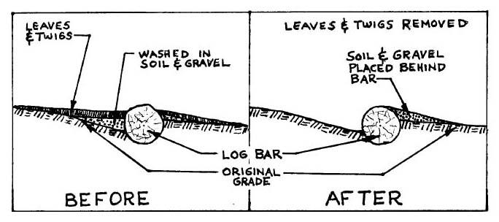
II-9

Make sure that you don't dig down below the original excavation unless you are sure it will improve the drainage performance. On log bars, 1/4 to 1/3 of the log should remain below grade on the uphill side. On a truly well built rock bar, the majority of the rock should be below grade. Unless you participated in its construction you can have no idea how deep it is. Proceed on faith and assume that the original excavation is correct.
Now it is time to fine tune the drainage way. Cut and remove any new root growth so that none can catch any floating debris or slow the water flow. Remove any other obstacles, such as rocks. Grade the sides of the outflow ditch to a moderate slope and round the top edges and bottom of the ditch. This will help prevent the ditch walls from sloughing off and clogging the ditch. Rake everything smooth and you are done.
When cleaning large numbers of waterbars, the most efficient means is a two person crew armed with a fire rake, shovel and hoe (hazel or grape). A crew such as this can clean 30 to 50 waterbars a day, depending on hiking distance and the condition of the waterbars. When working alone and/or doing just a few bars, any wide bladed digging tool will work, the grape hoe probably being the best.

Chapter III
SHOWING THE WAY
Blazing and Signing

With all the various controversial issues inherent to backcountry management, it seems odd that such a simple matter as trail marking should cause so much debate. The spectrum of opinion runs from the "blitzkrieg" method where paint consumption rivals the mileage of the worst gas guzzlers to the "natural selection" theory of weeding out the unwary hikers by losing them in the woods.
It is also somewhat puzzling that after decades of refining and standardizing by the benevolent giants (ATC, AMC, USFS, etc.), a significant amount of hikers and even some trail maintainers are not familiar with the conventions of trail marking. Perhaps a brief history of the evolvement of trail blazing would help clear things up.

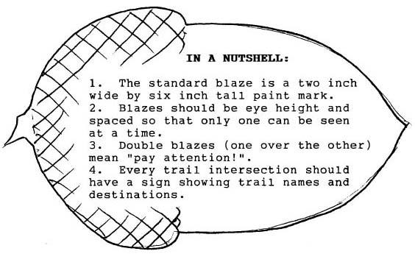

THE BLAZE
The traditional definition of the term "blaze" predates recreational hiking by many centuries and denotes a mark on a tree made by chipping off a piece of the bark. The blaze was used to mark the most efficient routes between inhabited locations before more substantial trails and roads could be cut. This traditional blaze was adopted by "trail blazers" when the first hiking routes were established in the nineteenth century.
As paint became more readily available and as trails became more numerous, the painted blaze was used to make the marks more obvious and later to differentiate between trails or trail systems. Land surveyors adopted identical methods for delineating boundaries and of course some confusion resulted.
III-2

Partly because of this confusion, and most likely also because of expediency, the true blaze was omitted and the paint mark was applied directly to the bark. But the term "blaze" has continued, and in its broader definition is most appropriate, for these paint marks certainly do "render conspicuous".
Free of the confines of the chipped area, the blazes took on various shapes limited only by the imagination of the blazer. Anyone who has hiked on Mt. Monadnock can testify to this, for many of the trails are named for their blazes (White Cross, Red Dot, White Arrow, etc.). Along came other contrivances, such as tin can lids and stamped metal trail emblems.
As trails became more numerous and popular, leaders of the hiking community saw a need to adopt a universally recognized method of trail marking. They wanted something that was easy to apply, did minimal damage to the tree, was visible without being overpowering, and would not be confused with various marks made by foresters and surveyors. The result is what the WODC uses today.
By general consensus and Forest Service standards, the accepted trail blaze is a two inch wide by six inch high rectangle painted on the bark of a tree. When properly applied, these markings will last for as much as ten years yet can easily be erased if the trail is relocated or discontinued. Most trails within the WMNF are marked with yellow blazes. White is reserved for the Appalachian Trail, and blue is usually used to mark side trails (spurs) of the Appalachian Trail, but WODC has elected to continue using. the traditional club color: medium blue.

THE RULES OF BLAZING
Trees are not always willing to grow where a blaze is needed so we must use a little latitude when practicing the art of blazing, but let's proceed on the assumption of at least a near perfect scenario.
At the trailhead and at any intersection, the first blaze should be prominently positioned far enough along the trail to provide a definite sense of direction yet close enough to be readily visible. Twenty to thirty feet would be the optimum range. Subsequent blazes should be positioned so that as you pass the previous blaze the next blaze becomes visible after traveling just a few feet along the trail. In theory, you should be able to see no more than one blaze at a time.
Different situations will certainly call for bending this rule. For example, in open hardwood forests it may be impossible to adequately blaze the trail without having more than one blaze visible from some points. Add a few inches of snow cover to an area like this and it becomes imperative that the blazes form a continuous line. Sudden changes in trail direction are another reason to add a blaze or two.
On the other hand, there are many places where the trail

III-3

is so obvious, such as in dense spruce, that the blazes may seem unnecessary. While it is definitely allowable to space them as much as 300 feet apart, they should not be entirely omitted. A hiker in unfamiliar territory derives a sense of security from seeing the occasional blaze.
The double blaze is a little used and often misinterpreted tool. It consists of two standard blazes, one above the other. It is most often used just before an intersection and therefore it is believed by many if not most hikers to be a warning of an approaching intersection. In actuality the double blaze is analogous to a flashing yellow light on the highway. It simply means look out, you should pay attention because something ahead could cause you to wander off the trail.
Sometimes the upper blaze is shifted to one side or the other to indicate an abrupt change in trail direction. There are a few of these on WODC trails but they are used sparingly because of the confusion they sometimes cause. Another option is to use a small arrow sign at the bend to guide hikers in the proper direction.

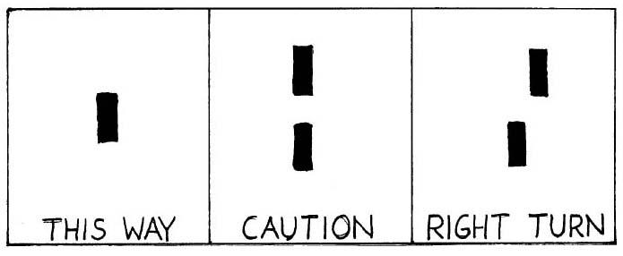

There are a few other considerations to keep in mind. Blazes should be at eye level or slightly higher. Above this they are apt to be obscured by branches and if they are much lower they can be covered by snow.
Blazing should be done in only one direction at a time. It is virtually impossible to do a decent job when travelling in the opposite direction. It is best to do the entire trail at one time, or at least complete a section between intersections. A sudden change in the blaze pattern or frequency can be confusing to the hiker.
Wilderness blazing can be a whole other can of worms. Paint marks on trees could be considered anathema to the wilderness spirit, but we owe it to the hikers to provide a well marked route. The best compromise is to use as few blazes as possible, while still allowing the alert hiker to stay on the trail.
If you determine that your trail needs to be reblazed, please contact the Trails Committee. We will be happy to

III-4

take care of it, or if you wish, we can set you up with the proper tools and know-how to do a superb job.

SIGNS
Signs provide the properly outfitted hiker (don't forget your map, compass and whistle!) with all the information needed to confidently follow a selected route. Without them, the possibility of a missed intersection is dramatically increased, which we all know can result in embarrassing if not dangerous consequences.
For the trail adopter, it is important to check the signs on a regular basis. Every trailhead and intersection should have a sign that identifies the trail name and shows destinations with directional arrows. Mileage should be included only when outside of wilderness boundaries.
Any side trails to views, shelters or springs should have a sign labeling it as such. Keep an eye out for those cases where blazing may not be enough to keep hikers on the trail. Perhaps a "Trail" or arrow sign would help.
Special considerations must be made in Wilderness areas. "Directional" signs, those that show trail names and destinations, are allowed; but "interpretive" signs, those that label items or provide information of an historical or scientific nature, should not be used. WODC has adopted the standard USFS Wilderness sign format. You will see more of these irregularly shaped five-sided signs as older ones are replaced.
As we keep saying, let us know what is needed on your. trail. The work trip reports provided to you make it an easy matter to report any damaged or missing signs.

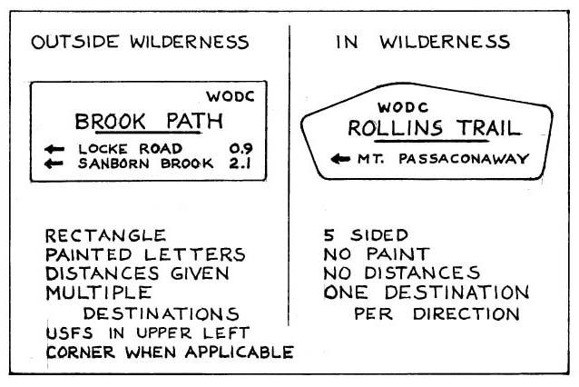

Chapter IV
GOOD NEIGHBORS, GRACIOUS GUESTS
Working with the Landowners

The term, "WODC trail", implies some esoteric sense of ownership. Yes, we created the trail system and have maintained it for a century, possibly establishing some prescriptive public rights. But beyond the small circle of club membership, in the much larger world of deeds, easements and real estate law we are merely permitted visitors.
In order to assure perpetuity of the trails and our continued involvement in their maintenance, we must respect the rights of the landowners and work with them to create a sense of trust and cooperation.
Generally speaking, these meetings and negotiations should be handled under the direction of the Executive Committee, but as trail adopters we should think of ourselves as WODC ambassadors and remember that our actions will be viewed as actions of the club.

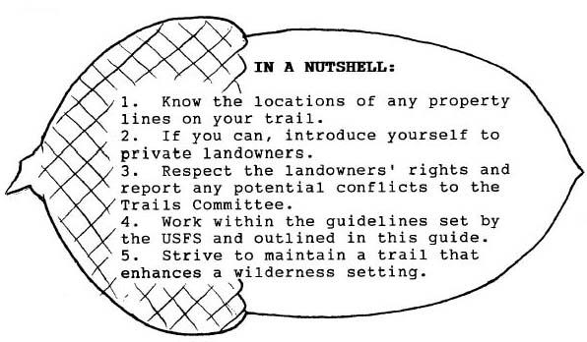

PRIVATELY OWNED LANDS
Although the majority of WODC trail mileage is within National Forest boundaries, all trailheads are on private land. The WODC map will show which trails are wholly or partly on private land.
If your trail falls into this category, you would be wise to familiarize yourself with the locations of property lines along the trail. On some trails this may not be feasible (on Brook Path it would keep a professional land surveyor busy for months), but the transition from private land to National Forest is usually well marked with signs and red paint.

IV-2

If you should get the opportunity to introduce yourself to your host/landowner, seize it. The benefits, both organizational and personal, could be many fold. WODC is fortunate that most of our neighbors and hosts are also active members in the club. An encounter with a Wonalanceter is almost always a pleasant experience.
Any trail clearing activity done in accord with Chapter I is acceptable on private land. Just be extra mindful of the placement of cuttings if you are near houses, yards or driveways. Existing trail drainage structures outside of any owner maintained areas (yards, driveways, etc.) may be cleaned and maintained. Any trail work above and beyond this should be done through the Trails Committee.
If the landowner does any work on or near the trail, or asks you to do any work that you suspect will be damaging to the trail or a hindrance to passage, do not take matters in your own hands. Contact the Trails Committee.

NATIONAL FOREST
The federal government is by far the largest and most demanding landowner we have to deal with. The Forest Service holds ultimate control over 18 of the 22 trails we maintain, and has very specific ideas of what should and should not be done. The WODC bears the official title of Cooperator with the Forest Service. This is a contractual arrangement which signifies that we, the club, agree to carry out our mission subject to the rules and under the supervision of the Forest Service.
The rules and guidelines for trail maintenance within' the National Forest are found in a myriad of manuals and regulations that often encompass the jurisdictional realm of agencies other than the Forest Service. This panoply of procedural precepts is subject to individual interpretation and is often the cause of numerous debates within the community of backcountry users and managers.
As individuals and as a club group, we have the opportunity to participate in these debates. The Forest Service is quite responsive to the natives. In fact it consistently seeks public input concerning it's proposed actions through what it calls "scoping" and is at least willing to listen to any unsolicited suggestions.
But as Cooperators with the Forest Service, we have the obligation to operate within the bounds of current procedural standards. Although we may and do lobby for those policies that we feel are in the best interest of the Forest, it is in our best interest to abide by those policies presently in effect.
The first three chapters of this guide attempt to outline the trail maintenance activities that the Forest Service considers to be routine and not requiring any review by their staff. As a trail adopter, you are free to perform any work that is done in accordance with this guide. Any actions above and beyond the scope of this guide should be cleared by the Trails Committee first.
IV-3

WILDERNESS
The 1984 New Hampshire Wilderness Act resulted in the creation of the Sandwich Range Wilderness. Although still part of the White Mountain National Forest and subject to the same regulations and policies as the rest of the Forest, it also has additional constraints that regulate the actions of the trail adopter. A look at the WODC map will show what sections of your adopted trail, if any, are in Wilderness.
The underlying intent of the Wilderness Act of 1964 was to designate and preserve pristine natural areas where humans are merely visitors; altering, taking and leaving nothing. Obviously, concessions had to be made to allow trail maintenance. These concessions appear to be quite reasonable when we imagine the absence of maintained trails resulting in thousands of back country enthusiasts tramping willy-nilly up the mountains.
Concessions aside, it behooves the trail adopter to consider the intent of the Wilderness Act when doing trail work. Thoughtful planning and careful work can result in a trail that appears to have occurred almost naturally. Close adherence to trail clearing methods described in this guide will help achieve the desired result.
There are also a couple of specific wilderness guidelines the trail adopter should consider. The treadway (the area of the trail that is actually walked on) should be no more than 18 inches wide. This does not mean that you should clear an 18 inch wide by 7 foot high rectangle through the vegetation. That would result in a very unnatural appearance. It does mean that when clearing trail, it is wise to contemplate the ramifications of your actions. The goal should be to create a natural looking corridor that will remain open for an entire growing season without inviting the hiker to step off the treadway.
This goal can usually be reached by careful brushing. Occasionally we encounter a situation where removing just enough of a plant to provide adequate passage results in an unattractive appearance but trimming it back to a more natural look might cause hikers to wander off the trail. The problem can usually be solved by choosing the more natural look and rearranging nearby downed branches to discourage any errant traffic. This is called "brushing in" and is also a useful method for fixing areas where undesirable paths have already occurred.
View clearing should not be done in Wilderness. As tempting as it may be, artificial clearing beyond that which is needed for trail passage is not consistent with the spirit and intent of the Wilderness Act.
Common sense and thoughtful application of accepted maintenance procedures will result in an attractive, natural pathway that will enhance the wilderness experience.


Trail: ______________________________________________________________________________
Trail Section (if applicable) From: ___________________________ To:_______________________
I/We undertake to maintain this trail as outlined below. I have indicated what aspects of the trail I will be responsible for, and the approximate month(s) in which I will do this work. I also agree to:
1. Perform all work in accordance with the WODC maintenance guidelines.
2. Observe applicable WMNF rules and Wilderness regulations.
3. Ask for help if needed or if I cannot meet the objectives outlined below.
4. Notify the Trails Committee if I am unable to continue to meet these goals.
5. Follow safety procedures and put safety first.

I will perform each activity in the month(s) I have checked | May | June | July | Aug | Sept | Oct | I will not be able to perform this work
Perform initial patrol to check for winter damage and urgent problems.
Remove major blowdowns (6" +) to make trail safe and passable.
Remove brush and minor blowdows to maintain trail width.
Clear all water bars and drainage areas to prevent mud and trail erosion.
Check for missing or damaged signs and blazing.
Check for general problems or incompatible use
What months do you visit or live in Wonalancet?
Adopter Name: __________________________________ Co-Adopter: __________________________________
Address: _______________________________________ Address: _____________________________________
______________________________________________ _____________________________________
Home Phone: __________________________________ Home Phone: __________________________________
Work Phone: _________________________________ Work Phone: __________________________________
Signature & Date: ______________________________ Signature & Date: _______________________________
This agreement will renew annually until terminated in writing by any party. We wish you many years of personal satisfaction and enjoyment from your public service and your trail.
Please return this form to: Wonalancet Out Door Club, Trails Committee, Wonalancet, NH 03897

Please use this form to keep the Trails Committee informed about the condition of your trail, and to help us identify any problems that may require special attention. In order to obtain matching funds, it is also important that we maintain records of all volunteer trail work. Please record each person and trip in the spaces on the back of this form. You may use one form for several trips, or even an entire season, but please return it to the Trails Committee by October 1st. Thank you!
Trail: __________________________________________ Report for ⁪ 1 trip ⁪ Several Trips

Report submitted by:_________________________________ ⁪ Adopter ⁪ Trail Crew ⁪ T/C
Please indicate the condition of the trail by checking the appropriate boxes below. For each aspect of the trail please indicate if it is OK, if you did work, or more work is needed by others.

 | OK | Did work | Needs work | Location / Comments
BRUSHING
4' wide by 8' high, cuttings flush to ground or limb, debris removed from trail and disposed of properly.
BLOWDOWNS
Cut beyond edge of clearing and removed from trail.
MULTIPLE PATHS
Brushed in with logs and branches.
BLAZES  Proper shape and color, adequate to follow trail, not overblazed |  | NA
SIGNS  At all trailheads and intersections, proper format. Damaged? Missing? |  | NA
WATERBARS
Clear of debris, downhill side adequately backed up with earth.
DITCHES
Clear of debris, properly shaped and sloped.
STEPS, ROCK & LOG WORK Stable, no rocking, not undermined, no side trails.
GULLIES & DEPRESSIONS Indicators of erosion. Look for evidence of water flowing in trail.
STANDING WATER & MUD Any wet section of trail, particularly where hikers widen treadway to avoid wet areas.
NA (not applicable) indicates work not normally performed by adopters. Please contact the Trails Committee if you would like to undertake this work.
Please list all days that work was done on your trail, using a separate line for each person. If you aren't sure about an earlier trip, even an estimate of the date and time is useful.

Work Date | Volunteer’s Name | Address (If not a regular volunteer).  Please enter only one person per line | Travel Hours (To and from trailhead) | Work Hours (Including hiking time)

Thanks for taking the time to complete this form. Your information will help us get a better sense of the condition of WODC trails and plan future trail work.

Please return this form to:
Wonalancet Out Door Club
Trails Committee
Wonalancet, NH 03897
BIBLIOGRAPHY
A list of selected publications about the use, maintenance and management of the back country.
Birchard, William Jr. & Proudman, Robert D.
Appalachian Trail Fieldbook; ATC, 1982
Intended to be used in the field for evaluation of trail conditions.
Trail Desiqn, Construction, and Maintenance; ATC, 1981
The Bible of the ATC, it offers a well written, intensive look at all trail aspects. Excellent illustrations and an in-depth section on tool use and care.
Hampton, Bruce & Cole, David.
Soft Paths; Stackpole Books; 1995
The how and why of low impact back country recreation.
"Nessmuk".
Woodcraft and Campinq; Dover Publications, 1963
Originally published in 1920, this book provides an interesting look at how things were done 75 years ago.
Proudman, Robert D. & Rajala, Reuben.
Trail Buildinq and. Maintenance, Second Edition; AMC, 1981
Written by people familiar with the White Mountains, this is a comprehensive treatise.
Twitchell, John, et. al.
Best Manaqement Practices for ~rosion C~ntrol Durinq Trail Maintenance and Construction; State of N.H. DRED, Trails Bureau, 1994
A State publication intended to help the trail maintainer abide by applicable regulations, it provides a useful reference for dealing with wet trail sections.
USDA Forest Service.
Sandwich Ranqe Wilderness Manaqement Plan; WMNF, 1989
Contains both general planning and specific recommendations that affect WODC trails.
Waterman, Laura and Guy.
Backwoods Ethics: Environmental . Issues for Hikers and Campers; The Countryman Press, 1993
Describes the "new ethic" of low impact hiking, camping and alpine management.
Wilderness Ethics: Preservinq the Spirit of Wildness; The Countryman Press, 1993
Concerned with preserving the wildness in wilderness.

